WIPRO TALENTNEXT PROGRAM
PBL HANDS-ON ASSIGNMENT
Name: M.VINAY
Roll No: 23BQ1A4951
PBL ID: DB_262790141
Date: 20-07-2026

ADVANCED SQL
- USING SUB QUERIES TO SOLVE QUERIES
- Display EMPNO, ENAME, DEPTNO of employees who work with employee KING
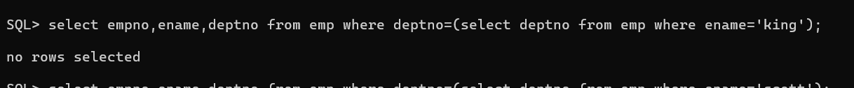
- Display employees who earn more than the average salary
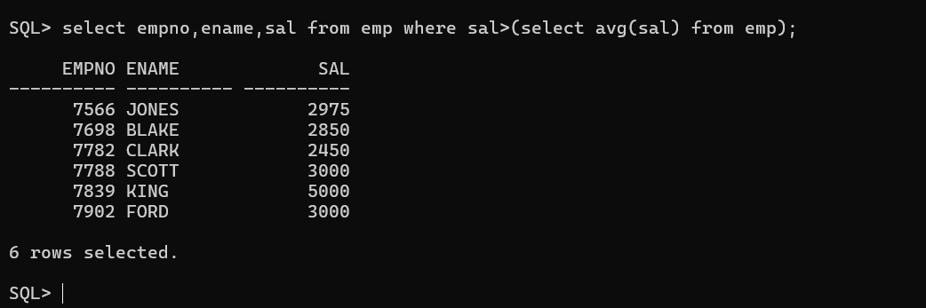
- Display ENAME and JOB who are Managers (Using EXISTS)
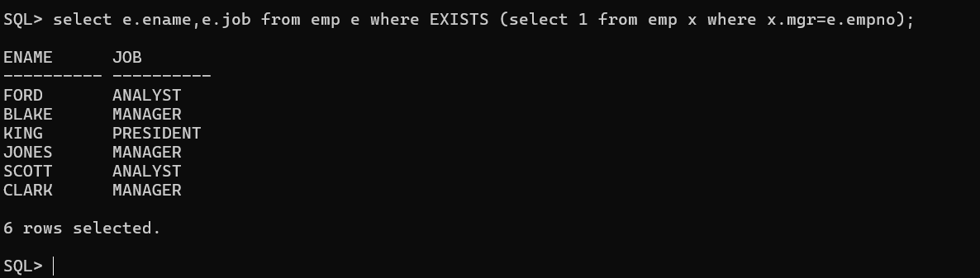
- Display employees who earn less than the least salary of DEPTNO 10 (Using ALL)
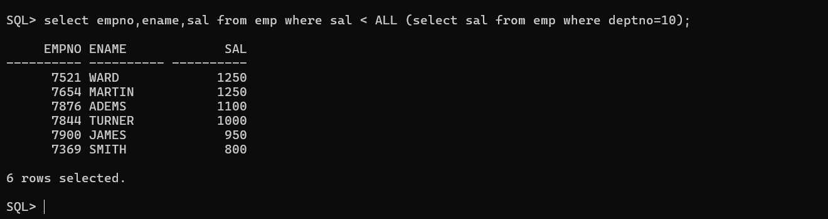

- Display employees having the same DEPTNO and MGR as employee SMITH, excluding SMITH
- Display employee number and name of employees who work in a department with any employee whose name contains 'R'
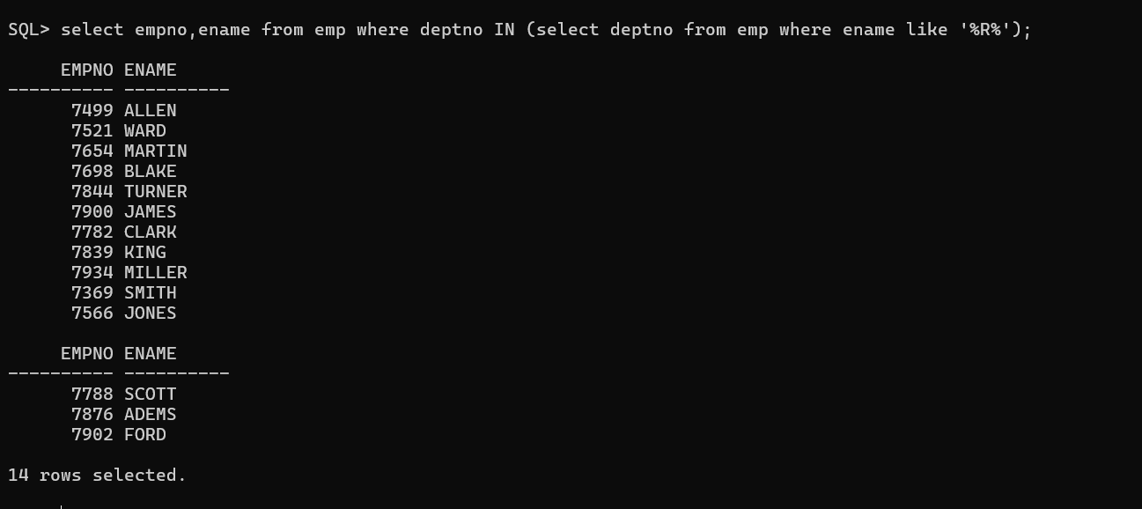
- Display ENAME, DEPTNO, JOB of employees who work in NEW YORK
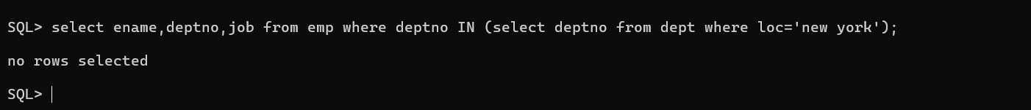
8. Prompt user for a location
9. Display name and salary of employees who report to KING
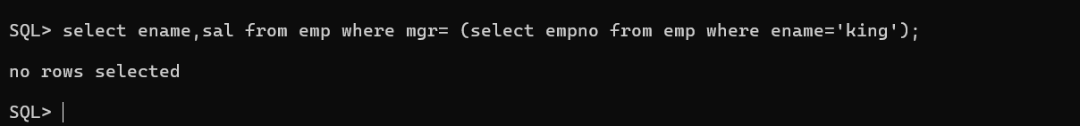
10. Display all employees working with JAMES
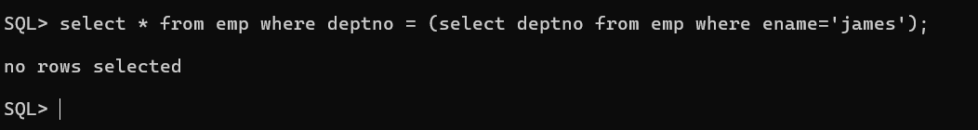
11. Display employees who earn less than the average salary of their respective departments (Correlated Subquery)
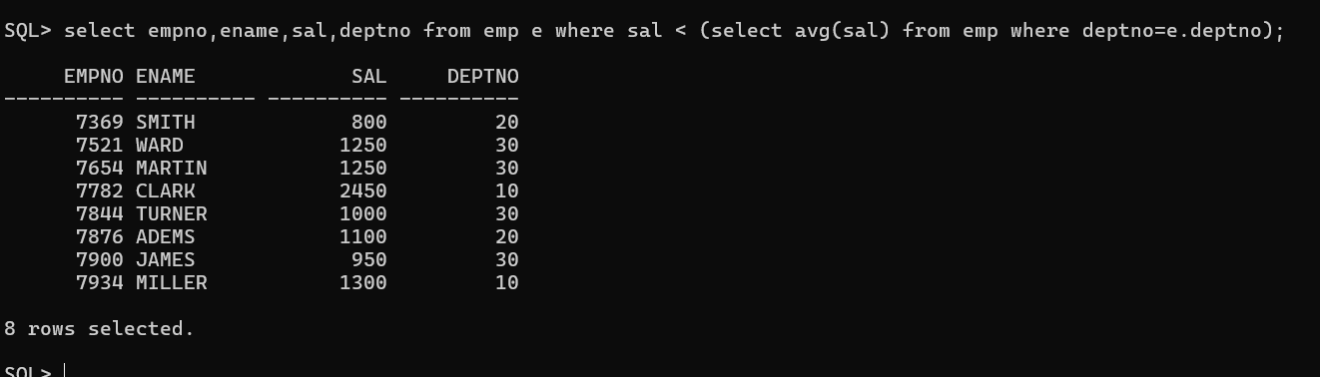
12. Display LOC and average salary of each location (Scalar Subquery)
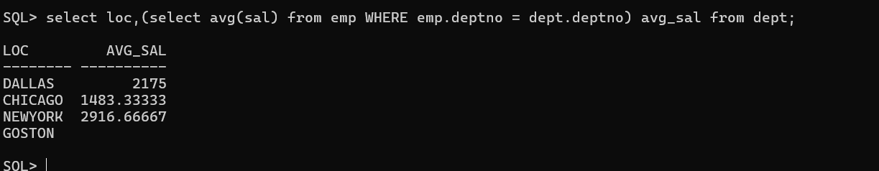
13. Display the least N salaries (Inline View)
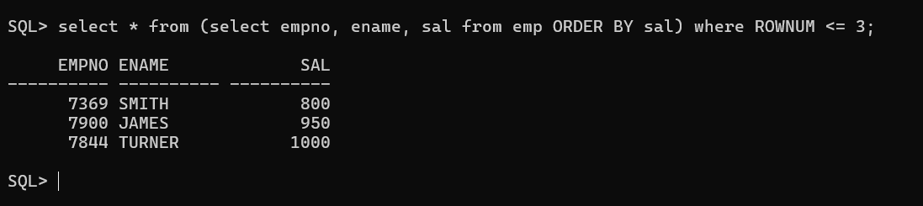
14. Display the last N rows from EMP table (Correlated Subquery)
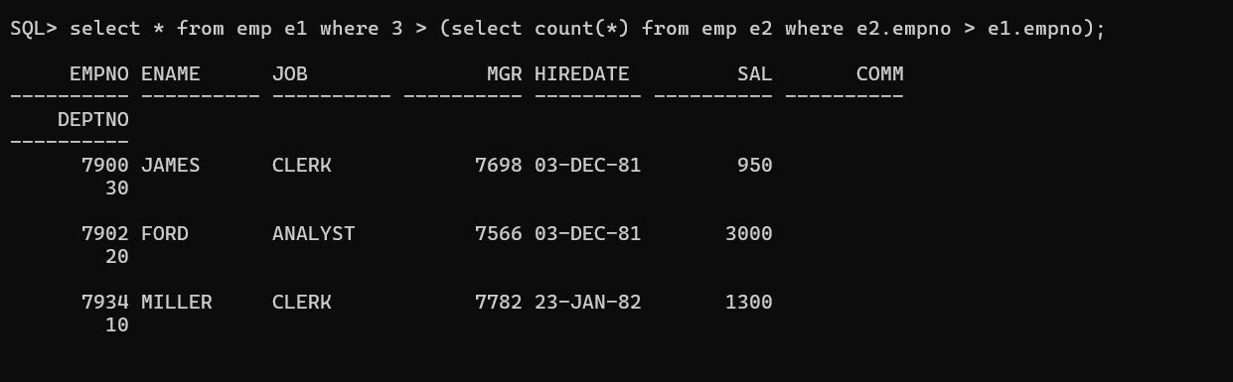
15. Display employees working in DALLAS and sort them by ENAME (Scalar Subquery)
16. Display employees who earn less than the average salary of their department and also display the average salary (Inline View)
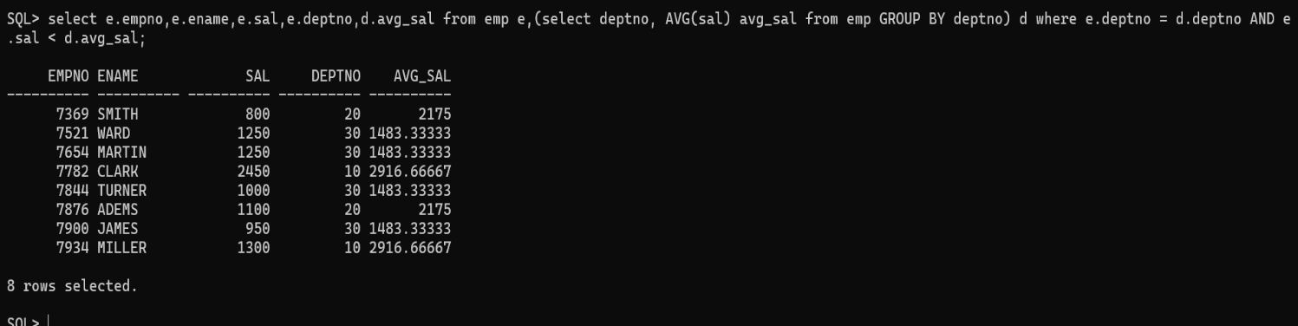
17. Display the LOC of departments whose total salary is less than the average salary of all employees (WITH Clause)

*Using DDL statements to create and manage tables

Create DEPT1 Table
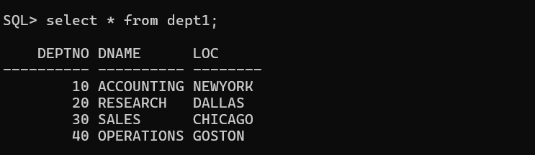
2. Create EMP1 Table
3. Create DEPT11 and EMP11 from DEPT1 and EMP1
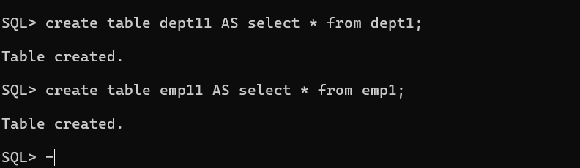
4. Add ADDRESS Column to EMP1
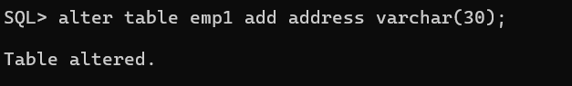
5. Rename SAL Column to SALARY
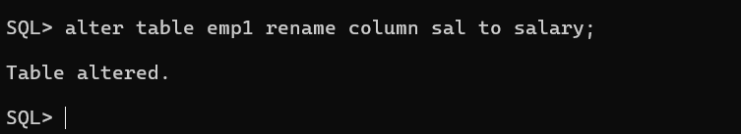
6. Rename Foreign Key Constraints and Verify
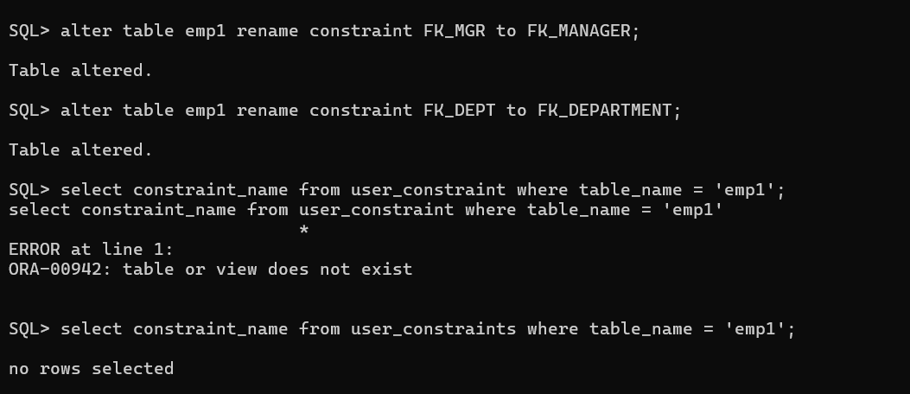
7. Increase ENAME Length to 40
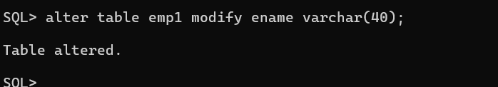
8. Drop NOT NULL Constraint from ENAME
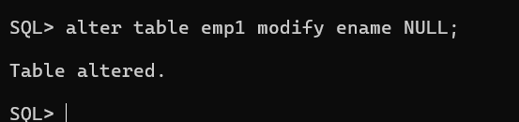
9. Comment on DEPT1 Table
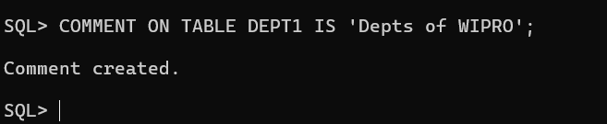
10. Comment on DEPTNO Column of DEPT1
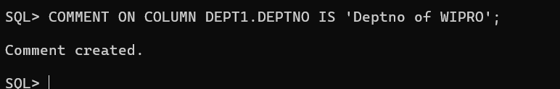
11. Comment on EMP1 Table
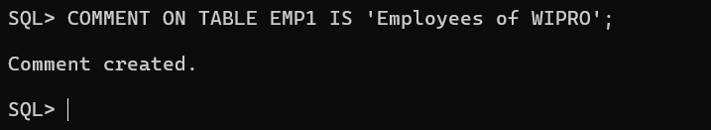
12. Create a comment on EMPNO of EMP1 table
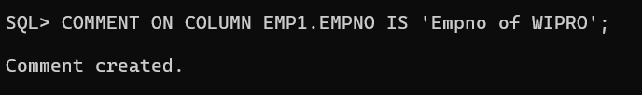
13. Remove all comments on tables and columns
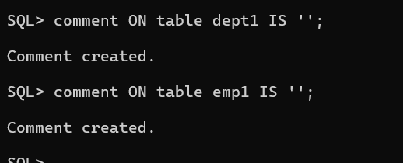
14. Set SAL and ENAME columns of EMP1 as UNUSED
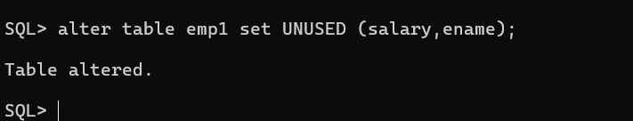
15. Drop the UNUSED columns
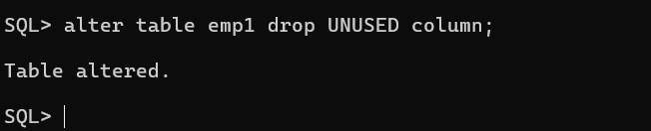
16. Drop EMP1 and DEPT1 tables
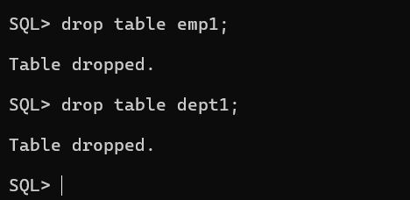
17. Create EMP1 from EMP table by copying data also
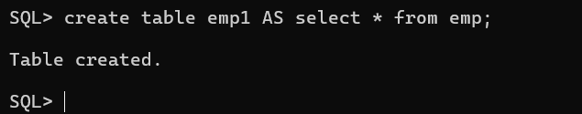
18. Rename EMP1 to EMP_TEST
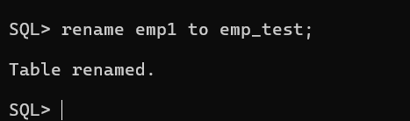
19. Truncate EMP_TEST and confirm
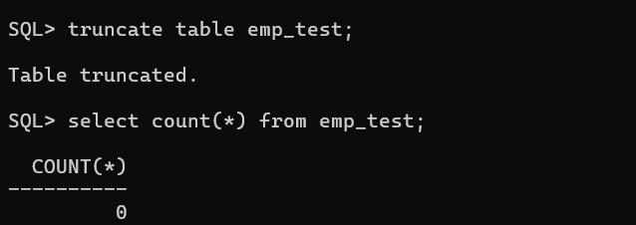
20. Create EMP2 with only EMPNO, ENAME, SAL columns and copy data
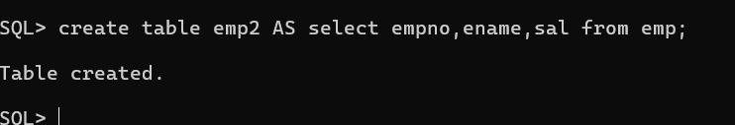
21. Drop EMP2 table
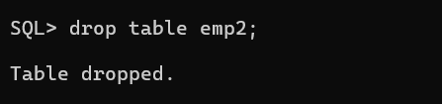
22. Create EMP2 again from EMP without copying data
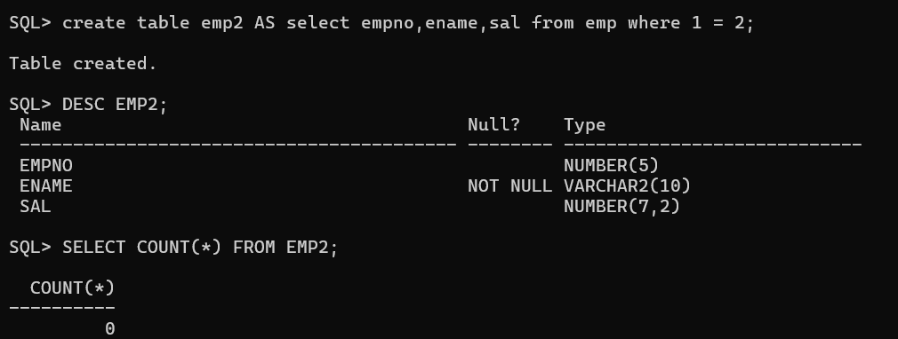
23. Drop EMP2 table

24. Flashback the first EMP2 table (the one that contained data) and check it
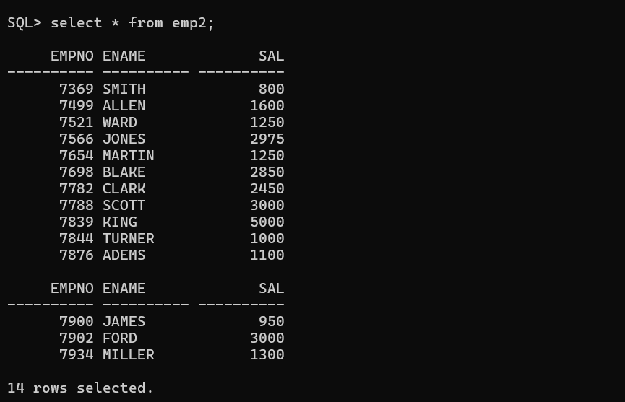

*Manipulating Data

1. Create EMPTEST from EMP (copy structure and data)
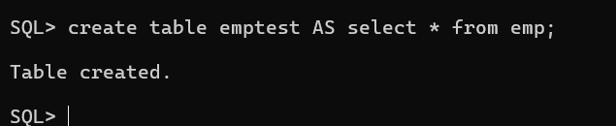
2. Insert a new row with current user as ENAME
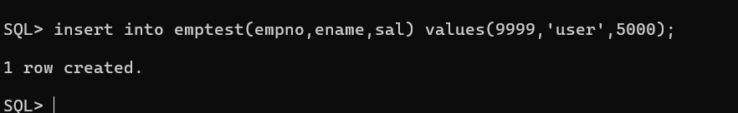
3. Increase TURNER's salary by 15%
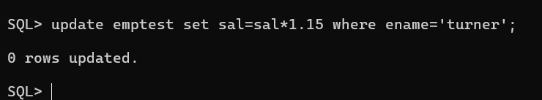
4. Update SMITH's salary with SCOTT's salary
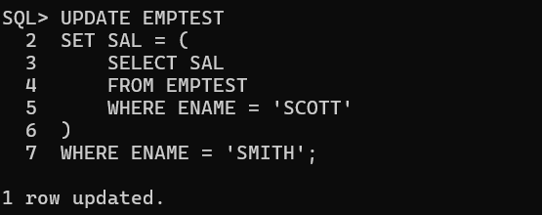
5. Increase salary by 10% for employees working in NEW YORK

6. Delete all COMM data
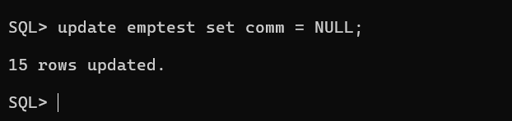
7. Delete employees working in SALES department

